# Name: Hariom Dilip Tripathi

## What is Java? Explain its features.

**Java** is a high-level, object-oriented programming language developed by Sun Microsystems (now owned by Oracle). It is widely used for building desktop, web, and mobile applications. Java is popular because of its **platform independence** — you can write code once and run it anywhere using the **Java Virtual Machine (JVM)**.

#### Key Features of Java:

* 1. **Platform Independent**: Java programs can run on any system with JVM — *"Write once, run anywhere."*
  2. **Object-Oriented**: Java uses objects and classes, supporting principles like inheritance, encapsulation, and polymorphism.
  3. **Simple and Easy to Learn**: Java has a clean and readable syntax.
  4. **Secure**: Java provides a secure environment through runtime checking, bytecode verification, and restricted access.
  5. **Robust**: Strong memory management and error-handling features (like try-catch blocks).
  6. **Multithreaded**: Supports multiple threads of execution (helps in games, animations, etc.).
  7. **High Performance**: Uses Just-In-Time (JIT) compiler for faster execution.
  8. **Distributed**: Java can build distributed applications using RMI and sockets.
  9. **Dynamic**: Java programs can load classes at runtime, making it flexible.

## Explain the Java program execution process.

#### Java Program Execution Process Using Notepad, CMD, and JDK

* 1. **Install JDK**
     + Download and install the Java Development Kit (JDK) from Oracle’s official site.

#### Set Environment Variable

* + - Add the JDK bin folder path to the system's PATH variable so you can run javac and java from anywhere in CMD.

#### Write Code in Notepad

* + - Open Notepad, write your Java code, and save the file with a .java extension (e.g., Hello.java).

#### Open CMD

* + - Open Command Prompt and navigate to the folder where your .java file is saved using the cd command.

#### Compile the Program

* + - Use javac FileName.java to compile the file. This creates a .class bytecode file.

#### Run the Program

* + - Use java FileName (without .class extension) to run the program.

#### JVM Executes the Program

* + - The Java Virtual Machine loads the .class file and executes the bytecode.

#### Java Program Execution Using VS Code and JDK

1. **Install JDK**
   * Download and install the latest **Java Development Kit (JDK)**.

#### Install VS Code

* + Download and install **Visual Studio Code** editor.

#### Install Java Extension Pack in VS Code

* + Open VS Code, go to Extensions, and install **"Java Extension Pack"** by Microsoft.

#### Write Java Program

* + Create a new file with .java extension (e.g., HelloWorld.java) and write your Java code.

#### Save the File

* + Save your file in a dedicated folder/project directory.

#### Run the Program

* + Click the **Run button** (▶) at the top or right-click and select **"Run Java"**.
  + OR use the terminal:
    - Compile: javac HelloWorld.java
    - Run: java HelloWorld

#### Program Executes

* + The output will be displayed in the **terminal window** inside VS Code.

## Write a simple Java program to display 'Hello World'

public class HelloWorld {

public static void main(String[] args) { System.out.println("Hello World");

}

}

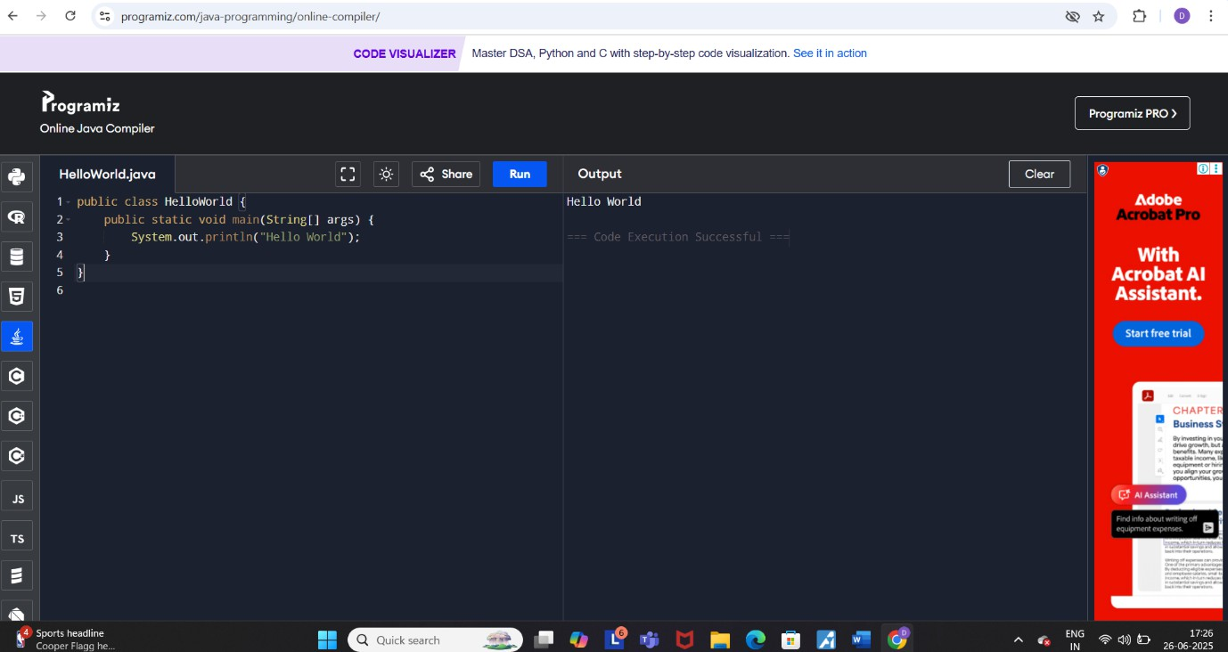

## What are Data Types in Java? List and Explain Them.

In Java, **data types** specify the kind of values a variable can store. Java is a statically-typed language, so each variable must be declared with a data type

#### Primitive Data Types (Basic)

These are the built-in, fixed-size types used to store simple values like numbers, characters, and logical values.

* **byte** – small whole numbers (e.g., age)
* **short** – slightly larger whole numbers
* **int** – commonly used for integers
* **long** – very large whole numbers
* **float** – decimal numbers (less precision)
* **double** – decimal numbers (more precision)
* **char** – single character (e.g., 'A', '3')
* **boolean** – stores true or false

These types directly store values in memory and are not objects.

#### Non-Primitive Data Types (Reference Types)

These types are based on **classes** and are used to store complex data.

#### Class

A class is a blueprint for creating objects. It defines **properties (variables)** and **methods (functions)**. For example, a Car class might have color, speed, and a method drive().

#### Object

An object is an instance of a class. It represents a real-world entity created from the class blueprint. For example, Car myCar = new Car();

#### Interface

An interface defines a set of abstract methods (without implementation). A class

implements an interface to follow its structure. It's used to achieve abstraction and multiple inheritance.

Example: interface Printable { void print(); }

1. **String** – Sequence of characters (e.g., "Hello")
2. **Arrays** – Collection of elements (e.g., int[] arr = {1, 2, 3};)

## What is the Difference Between JDK, JRE, and JVM?

#### JVM (Java Virtual Machine)

* **JVM** is the **engine** that runs Java bytecode.
* It provides a **runtime environment** for executing Java programs.
* It is **platform-dependent**, meaning each OS has its own version of JVM.
* It handles memory management, garbage collection, and bytecode execution.

#### JRE (Java Runtime Environment)

* **JRE** is a **package** that contains **JVM + Java class libraries** (like rt.jar).
* It is used to **run** Java applications but **cannot compile** them.
* It does **not include development tools** like the Java compiler.

#### JDK (Java Development Kit)

* **JDK** is a full **development package** for Java.
* It contains everything in the **JRE**, **plus** tools like javac (compiler), javadoc, and debugger.
* It is used to **write, compile, and run** Java programs.

## What are Variables in Java? Explain with Examples.

#### What is a Variable?

In Java, a **variable** is a **name given to a memory location** that stores a value. It acts like a container to hold data during the execution of a program. Every variable must have a **data type**, which defines what kind of value it can store.

#### Types of Variables in Java:

* 1. **Local Variable**
     + Declared inside a method or block.
     + Only accessible within that block.
     + Must be initialized before use.

#### Instance Variable

* + - Declared inside a class but **outside methods**.
    - Belongs to the object (each object has its own copy).
    - Does **not use static** keyword.
  1. **Static Variable** (Class Variable)
     + Declared with the static keyword.
     + Belongs to the **class**, not objects.
     + All objects share the same static variable.

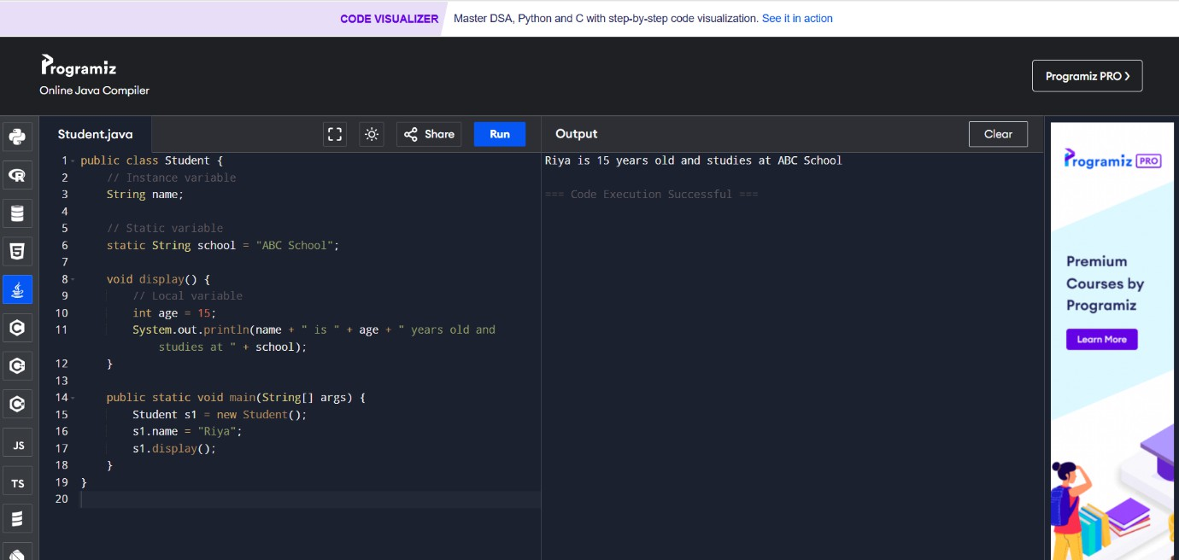

## What are the different types of operators in Java?

In Java, **operators** are special symbols used to perform **operations** on variables and values. They help in performing tasks like arithmetic, comparison, assignment, etc.

#### Types of Operators in Java:

* 1. **Arithmetic Operators**

Used for basic mathematical operations:

• + (Addition)

* - (Subtraction)
* * (Multiplication)
* / (Division)
* % (Modulus - Remainder)

#### Relational (Comparison) Operators

Used to compare two values:

• == (Equal to)

* != (Not equal to)
* > (Greater than)
* < (Less than)
* >= (Greater than or equal to)
* <= (Less than or equal to)

#### Logical Operators

Used for logical conditions:

* && (Logical AND)
* || (Logical OR)
* ! (Logical NOT)

#### Assignment Operators

Used to assign values to variables:

• = (Assign)

• +=, -=, *=, /=, %= (Compound assignment)

#### Unary Operators

Operate on a single operand:

• +, - (Unary plus, minus)

• ++ (Increment)

* -- (Decrement)
* ! (Logical NOT)

#### Bitwise Operators

Operate on bits:

* & (Bitwise AND)
* | (Bitwise OR)
* ^ (Bitwise XOR)
* ~ (Bitwise Complement)
* <<, >>, >>> (Bit shifts)

## Explain control statements in Java (if, if-else, switch).

**if Statement**

#### Syntax

if (condition) {

// code to execute if condition is true

}

Ex.

int number = 10; if (number > 0) {

System.out.println("Positive number");

}

#### if-else Statement

Syntax

if (condition) {

// code if true

} else {

// code if false

}

Ex.

int number = -5; if (number >= 0) {

System.out.println("Positive");

} else {

System.out.println("Negative");

}

else-if Ladder Syntax

if (condition1) {

// code

} else if (condition2) {

// code

} else {

// default code

}

Ex.

int marks = 75;

if (marks >= 90) { System.out.println("Grade A");

} else if (marks >= 60) { System.out.println("Grade B");

} else {

System.out.println("Grade C");

}

#### switch Statement

Syntax

switch (expression) { case value1:

// code break;

case value2:

// code break;

default:

// default code

}

Ex.

int day = 3;

switch (day) { case 1:

System.out.println("Monday"); break;

case 2:

System.out.println("Tuesday"); break;

case 3:

System.out.println("Wednesday"); break;

default:

System.out.println("Invalid day");

}

## Write a Java program to find whether a number is even or odd.

1. 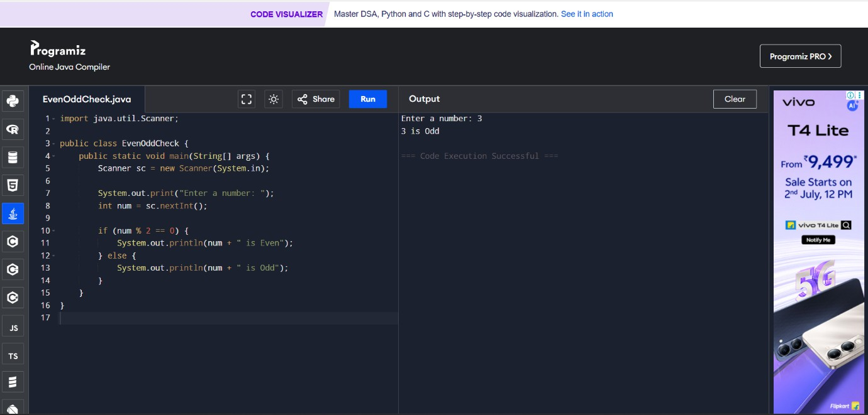**What is the difference between while and do-while loop?**

While loop

In a **while loop**, the condition is checked **before** the loop body executes A while loop may **not run at all** if the condition is false initially.

Use while when you want to check the condition **first**, and do-while when the loop must run **at least once**.

Syntax

while (condition) {

// code to execute repeatedly

}

Ex.

int i = 1;

while (i <= 3) {

System.out.println("Count: " + i); i++;

}

Output Count: 1

Count: 2

Count: 3 Do-While

In a **do-while loop**, the condition is checked **after** the loop body executes. A do-while loop **always runs at least once**, even if the condition is false.

Syntax do {

// code to execute repeatedly

} while (condition); Ex.

int i = 1; do {

System.out.println("Count: " + i); i++;

} while (i <= 3); Output

Count: 1

Count: 2

Count: 3

# 2.Object-Oriented Programming (OOPs)

## What are the main principles of OOPs in Java? Explain each.

Object-Oriented Programming (OOP) in Java is based on a set of core principles that aim to make software more modular, reusable, and easier to maintain. The main principles of OOP in Java are:

#### Encapsulation

**Definition**: Encapsulation is the practice of hiding the internal state and behavior of an object and exposing only what is necessary.

#### How it works:

* + Achieved by using **private** variables and **public** getter and setter methods.
  + Keeps the data safe from outside interference and misuse.

Ex.

public class Person { private String name;

public String getName() { return name;

}

public void setName(String name) { this.name = name;

}

}

#### Inheritance

**Definition**: Inheritance allows one class to acquire the properties (fields) and behaviors (methods) of another class.

#### How it works:

* + The class that inherits is called the **subclass** or **child class**.
  + The class being inherited from is the **superclass** or **parent class**.
  + Promotes **code reuse**.

Ex.

class Animal { void eat() {

System.out.println("This animal eats food.");

}

}

class Dog extends Animal { void bark() {

System.out.println("The dog barks.");

}

}

#### Polymorphism

**Definition**: Polymorphism means "many forms" and allows objects to be treated as instances of their parent class rather than their actual class.

#### Types:

* + **Compile-time polymorphism (Method Overloading)**: Multiple methods with the same name but different parameters.
  + **Runtime polymorphism (Method Overriding)**: A subclass provides a specific implementation of a method already defined in its superclass.

Ex.

class Animal { void sound() {

System.out.println("Animal makes a sound");

}

}

class Dog extends Animal { @Override

void sound() {

System.out.println("Dog barks");

}

}

#### Abstraction

**Definition**: Abstraction is the concept of hiding the complex implementation details and showing only the essential features of an object.

#### How it works:

* + Achieved using **abstract classes** and **interfaces**.
  + Helps in reducing complexity and isolating impact of changes. abstract class Shape {

abstract void draw();

}

class Circle extends Shape { void draw() {

System.out.println("Drawing a circle");

}

}

## What is a Class and an Object in Java?

#### Class in Java

A **class** is a **blueprint or template** for creating objects. It defines properties (variables) and behaviors (methods) that the objects created from the class will have.

#### Syntax:

class ClassName {

// fields (variables)

// methods

}

Ex.

class Car {

// Properties String color;

int speed;

// Method void drive() {

System.out.println("The car is driving.");

}

}

#### Object in Java

An **object** is a real-world **instance** of a class. It contains actual values and can use the methods defined in the class

#### Syntax:

ClassName obj = new ClassName();

#### Example:

public class Main {

public static void main(String[] args) {

Car myCar = new Car(); // Creating object myCar.color = "Red"; // Setting property myCar.speed = 100;

System.out.println("Car color: " + myCar.color); System.out.println("Car speed: " + myCar.speed); myCar.drive(); // Calling method

}

}

Output:

Car color: Red Car speed: 100

The car is driving.

## Write a program using class and object to calculate area of a rectangle

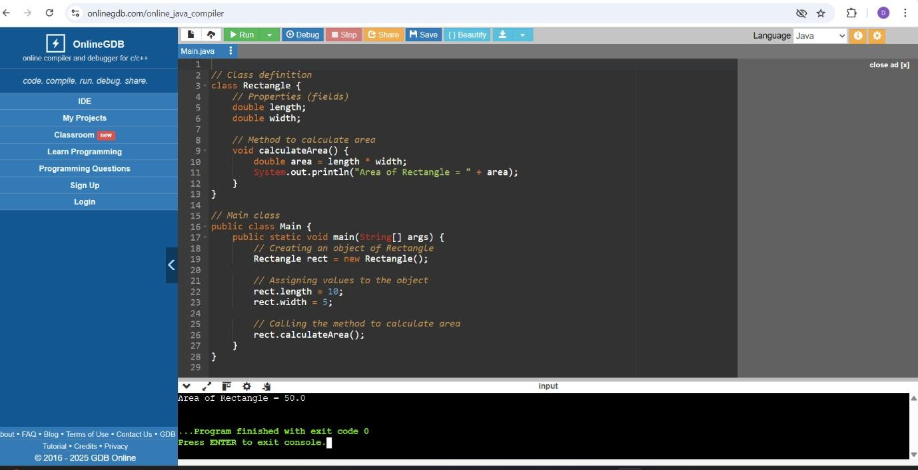

1. **Explain inheritance with real-life example and Java code.**

#### What is Inheritance?

Inheritance is one of the main principles of OOP. It allows a class (called **child** or **subclass**) to

**inherit** properties and methods from another class (called **parent** or **superclass**). **Real-Life Example:**

Think of a **Vehicle** class as a base class.

Then you have **Car**, **Bike**, and **Bus** as subclasses that inherit common properties (like speed, color) and behaviors (like move) from **Vehicle**.

**Java Code Example:**

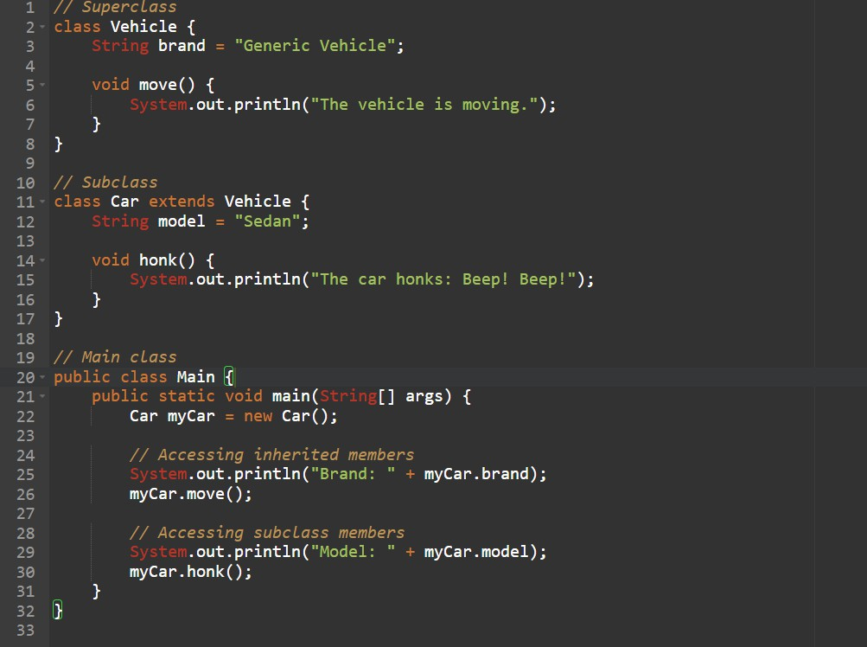

**Output**

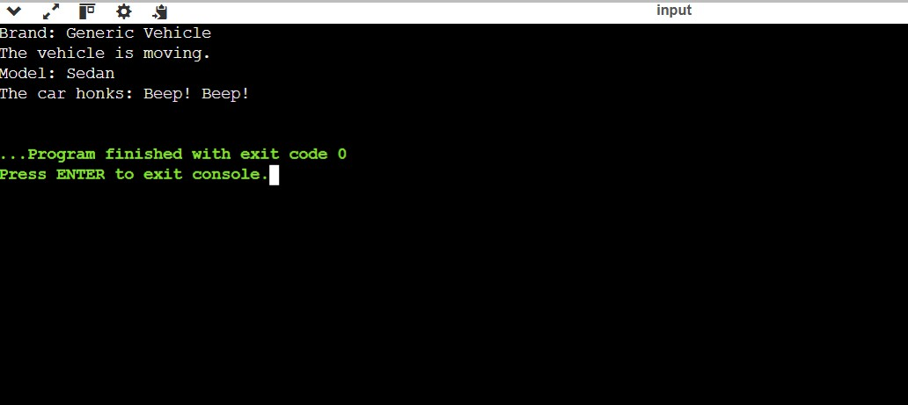

## What is polymorphism? Explain with compile-time and runtime examples

#### What is Polymorphism in Java? Definition:

**Polymorphism** means "**many forms**". It allows the **same method** or **action** to behave

**differently** based on the **object** that is invoking it. In Java, polymorphism is of **two types**:

#### Compile-Time Polymorphism (Method Overloading)

* + - **Same method name**, but **different parameter list**.
    - Decided **at compile time**.
    - Also called **Static Polymorphism**. Example:

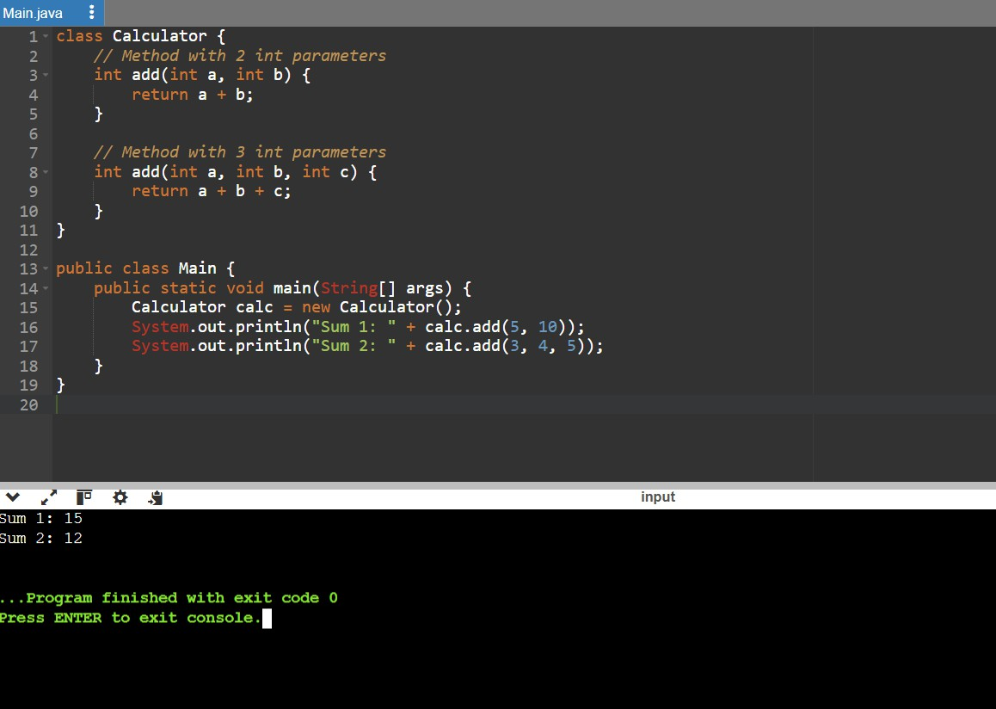

#### Runtime Polymorphism (Method Overriding)

* + - **Subclass overrides** a method of its **superclass**.
    - Resolved **at runtime**.
    - Also called **Dynamic Polymorphism**

### Example:

1. 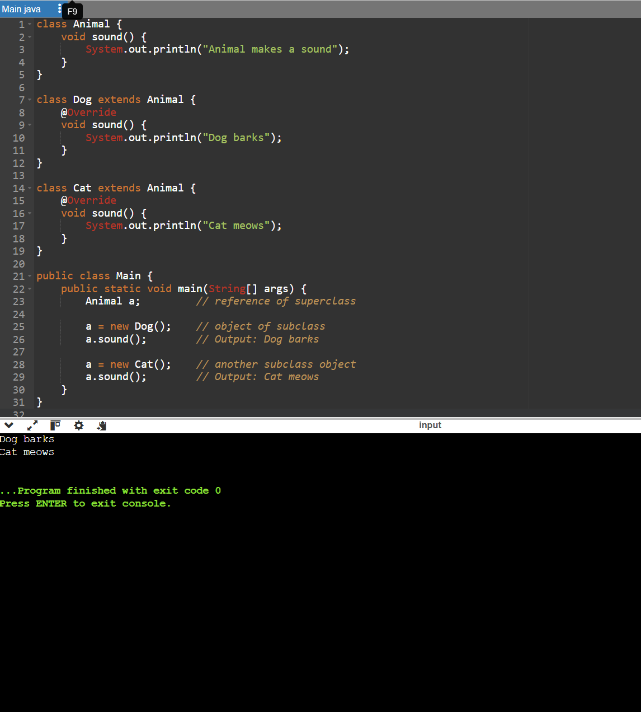**What is Method Overloading and Method Overriding in Java?**
2. **Method Overloading Definition:**

**Method Overloading** means **defining multiple methods with the same name** in the

**same class**, but with **different parameters** (number, type, or order).

* + - Happens at **compile-time** → **Compile-Time Polymorphism**.
    - Improves **readability** and **reusability**.

### Example of Method Overloading:

#### Method Overriding Definition:

**Method Overriding** means a **subclass** provides a **specific implementation** of a method that is **already defined in its superclass**.

* + Happens at **runtime** → **Runtime Polymorphism**.

#### Must have same method name, parameters, and return type.

* + Use @Override annotation (optional but recommended).

**Example of Method Overriding**:

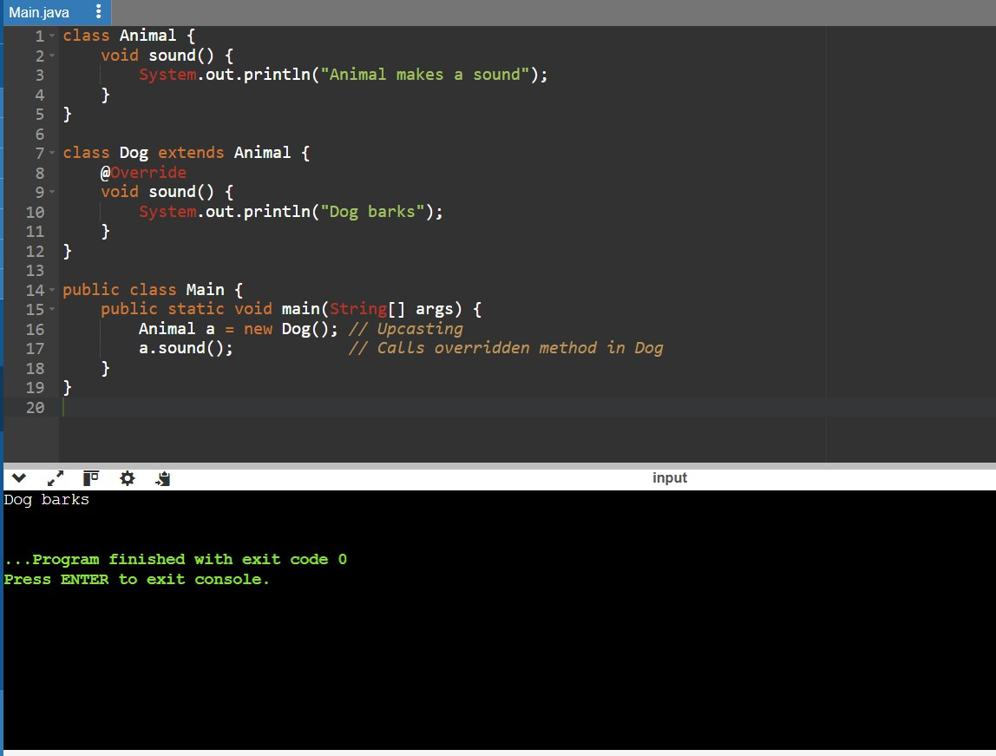

## What is encapsulation? Write a program demonstrating encapsulation.

#### What is Encapsulation in Java? Definition:

**Encapsulation** is the OOP principle of **hiding the internal details** of a class and

**restricting direct access** to some of its components.

It’s used to **protect data** by making variables **private** and providing **public getter and setter methods**.

#### Key Concepts:

* **Private variables** → can't be accessed directly from outside.
* **Public methods** (getters/setters) → used to read/update the values.

#### Real-Life Analogy:

Think of a capsule (medicine). You can use it, but you can’t see or modify what’s inside — this is **encapsulation**.

**Java Program Demonstrating Encapsulation:**

## What is abstraction in Java? How is it achieved?

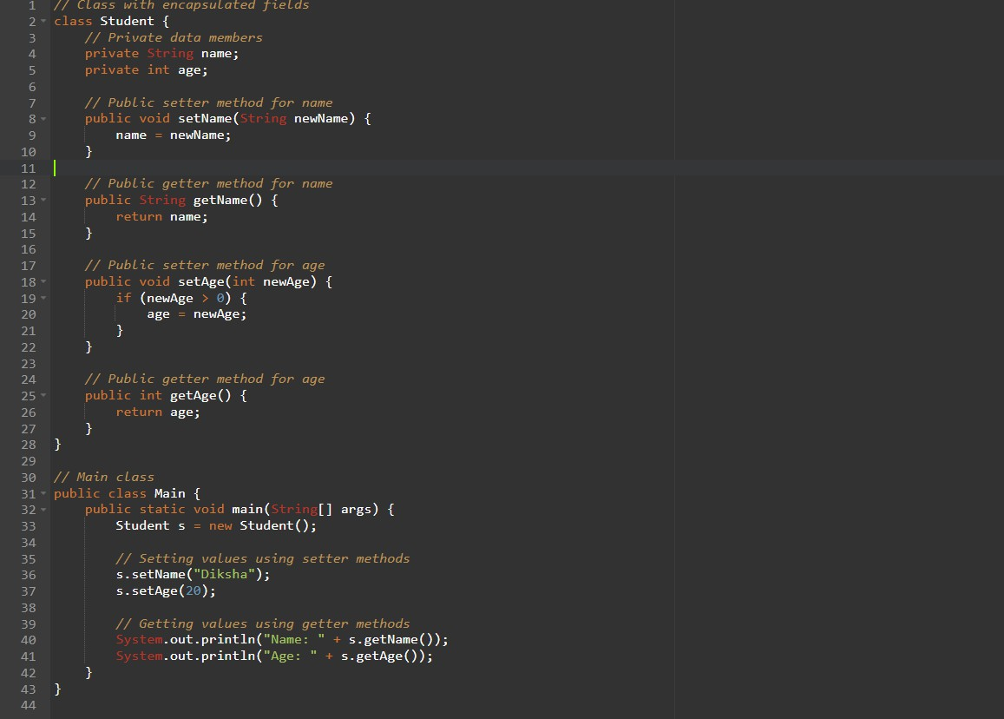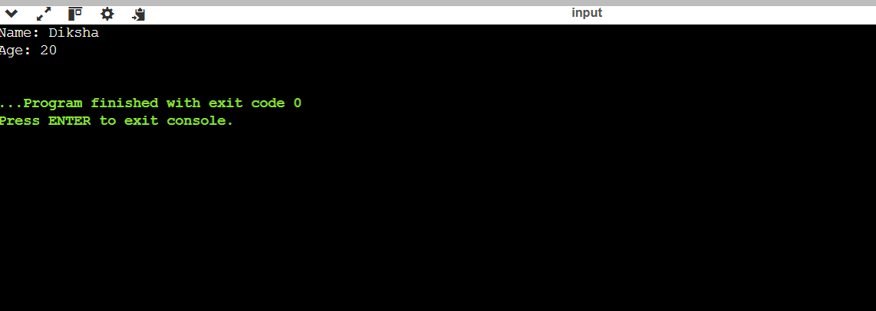

#### What is Abstraction in Java? Definition:

**Abstraction** in Java is the process of **hiding internal implementation details** and **showing only the essential features** to the user.

It helps reduce complexity by letting you focus on **what an object does**, instead of **how it does it**.

#### Example in Real Life:

When you drive a car, you use the **steering wheel, accelerator, brake** – you don’t know the internal mechanics.

That’s abstraction — you interact with only the **necessary parts**. **How Abstraction is Achieved in Java:**

Java provides two main ways:

* 1. **Abstract Classes**
  2. **Interfaces**

1. **Abstract Class**
   * A class declared with the abstract keyword.
   * Can have both **abstract methods** (without body) and **regular methods**.
   * Cannot be instantiated directly.

#### Example:

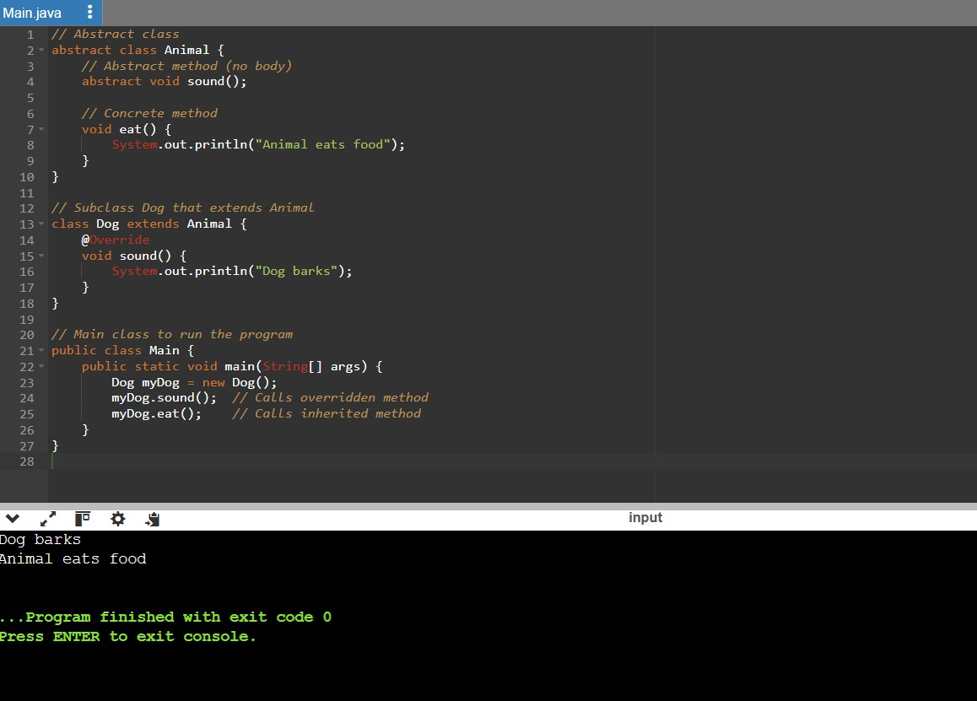

1. **Interface**
   * Contains only **abstract methods** (by default) and **constants**.
   * A class implements the interface and provides method definitions.
   * Supports **multiple inheritance**. **Example:**

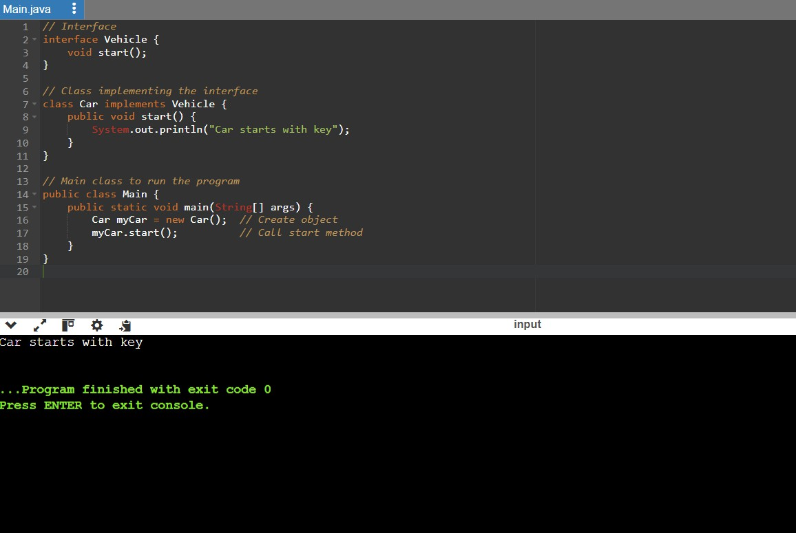

## Explain the difference between abstract class and interface.

#### Abstract Class

* Can have both abstract and regular (concrete) methods.
* Can have constructors.
* Can have variables (fields) with any access modifier.
* Supports single inheritance only.
* Used when you want to share common behavior among subclasses.

### Syntax Example

abstract class Animal {

abstract void sound(); // abstract method void eat() { // concrete method

System.out.println("Animal eats food");

}

}

#### Interface

* Contains only abstract methods (until Java 7), and only public methods.
* Cannot have constructors.
* Variables are always public, static, and final.
* Supports multiple inheritance (a class can implement multiple interfaces).
* Used when you want to define a set of rules or a contract.

Syntax Example interface Vehicle {

void start(); // abstract method

}

## Create a Java program to demonstrate the use of interface

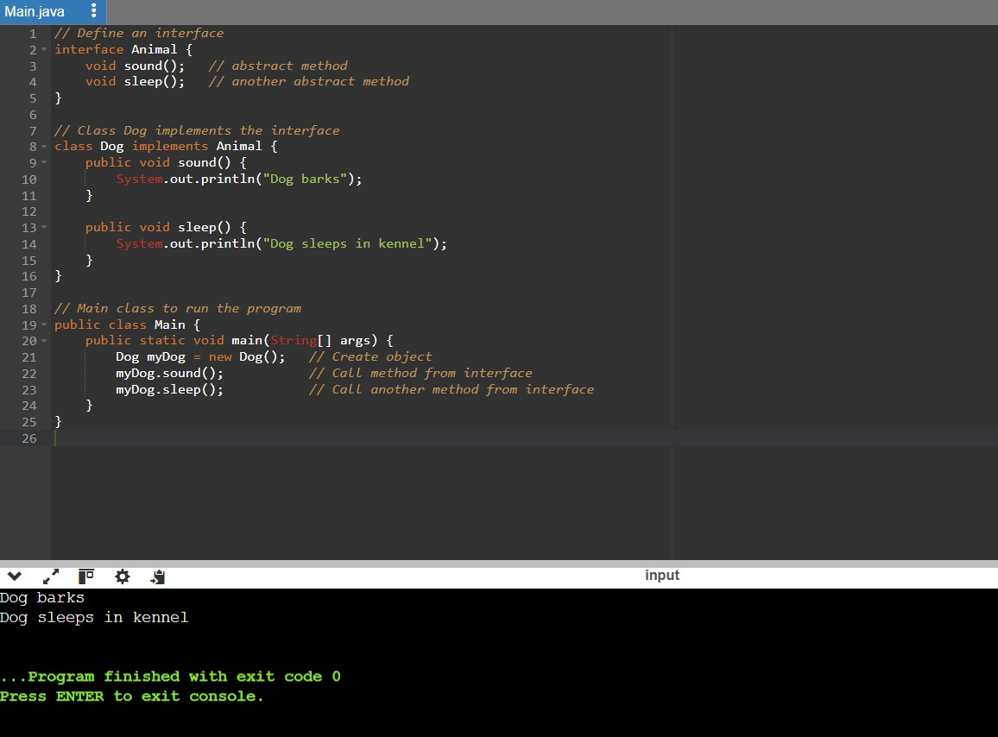

#### Explanation:

* The Animal interface defines **two abstract methods**: sound() and sleep().
* The Dog class **implements** the interface and provides concrete definitions for both methods.
* In the main() method, we create a Dog object and call those methods to demonstrate the use of the interface.

## What is method overloading and method overriding? Show with examples.

### Method Overloading

#### Definition:

Method Overloading means **defining multiple methods with the same name** in the

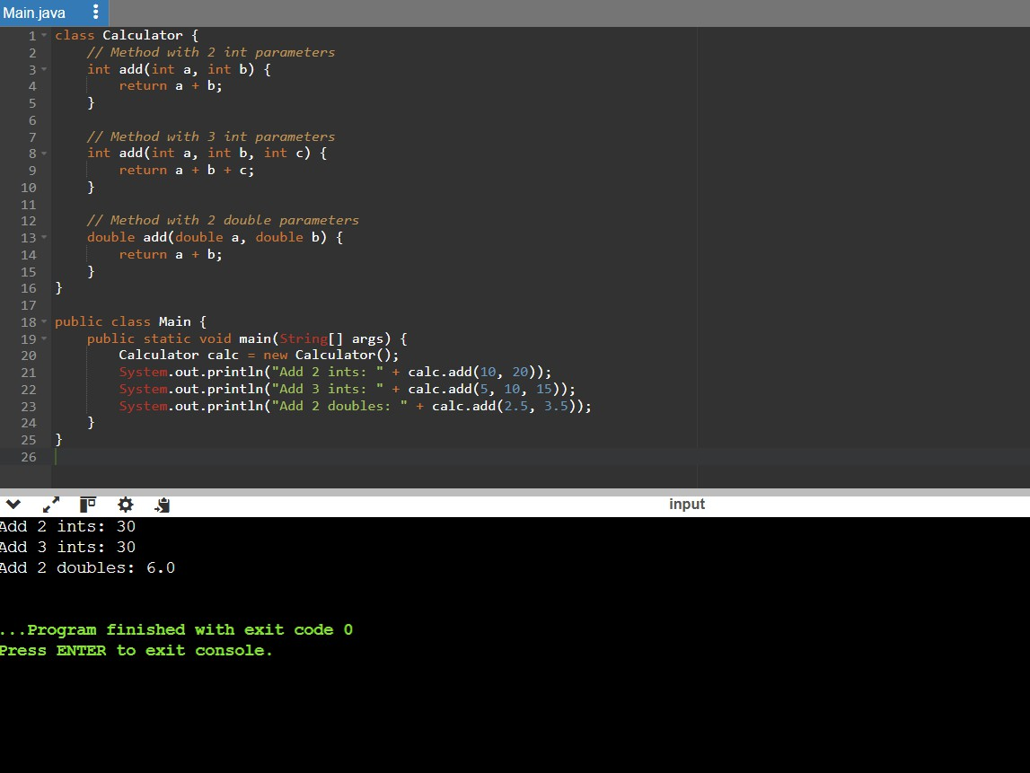**same class**, but with **different parameters** (number, type, or order). It is an example of **compile-time polymorphism**.

#### Method Overriding

**Definition:**

Method Overriding means a **subclass** provides a specific implementation of a method that is

**already defined in its superclass**, with the **same name and parameters**. It is an example of **runtime polymorphism**.

**Example:**

